TAY

1)Login Screen.

1a)Login API.

1b)Forgot Password API.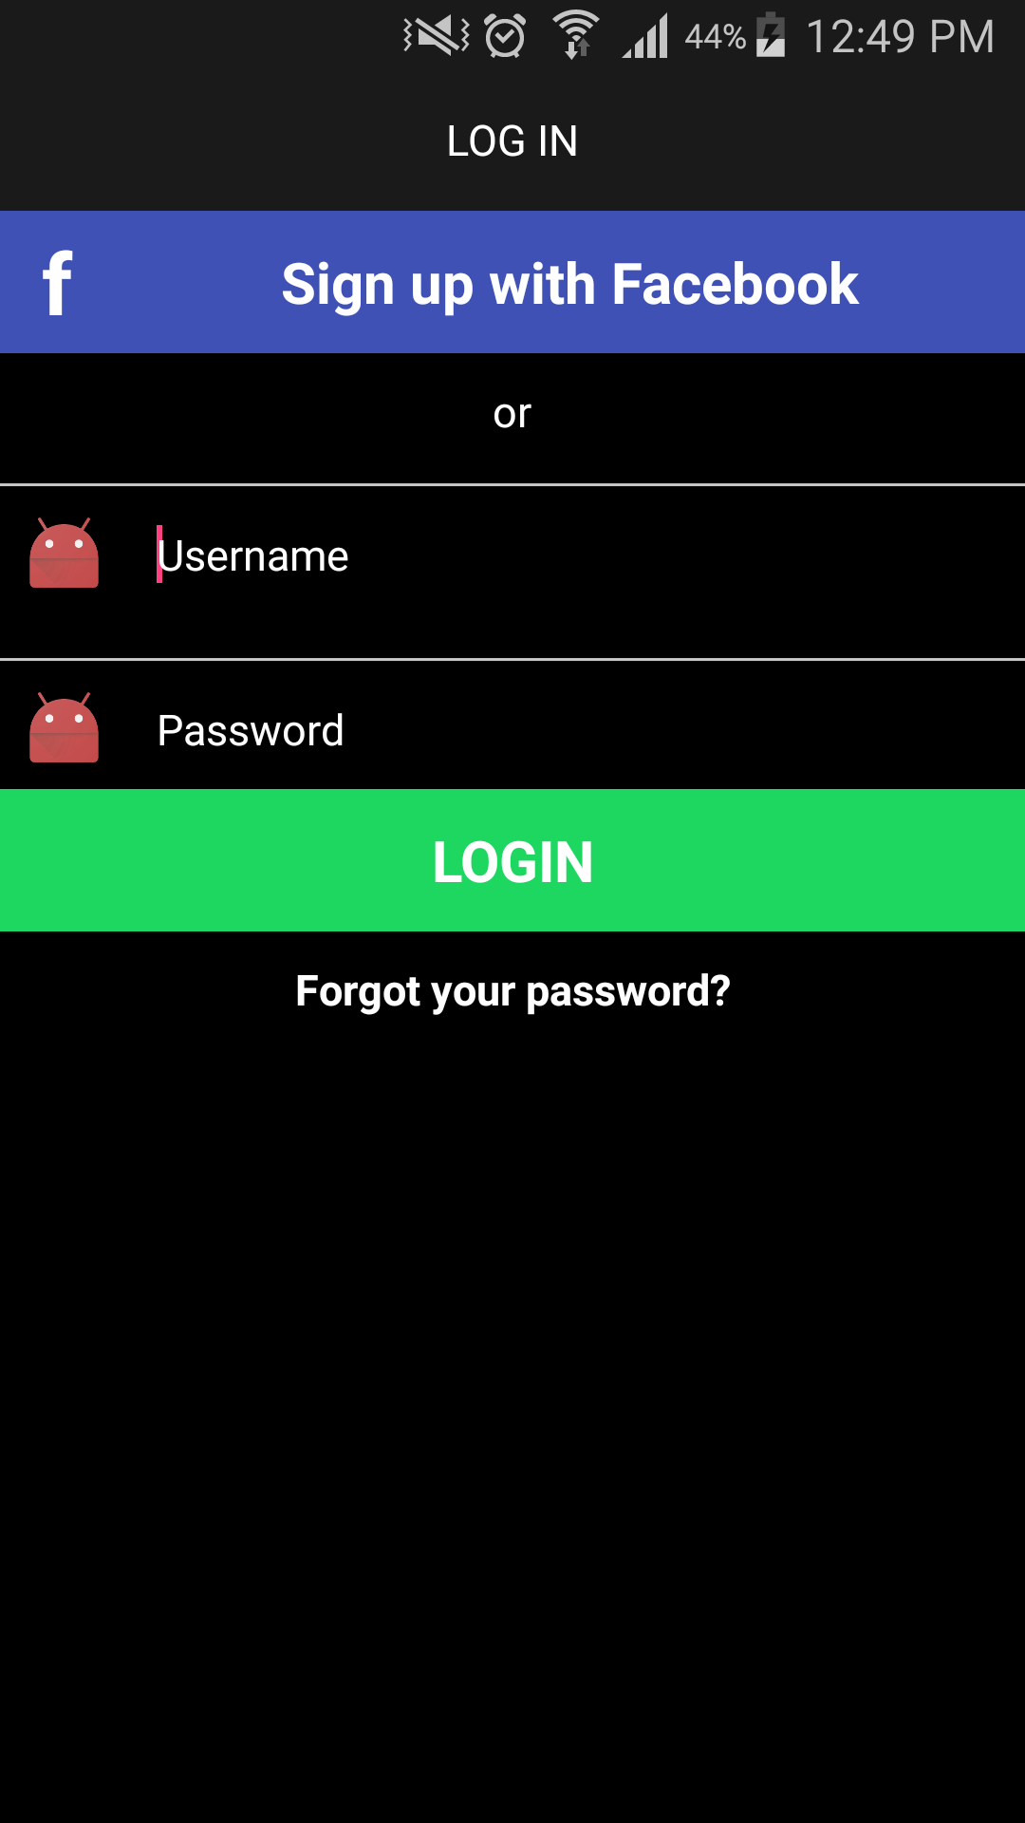

2)Signup Screen.

2a)Sign-up API.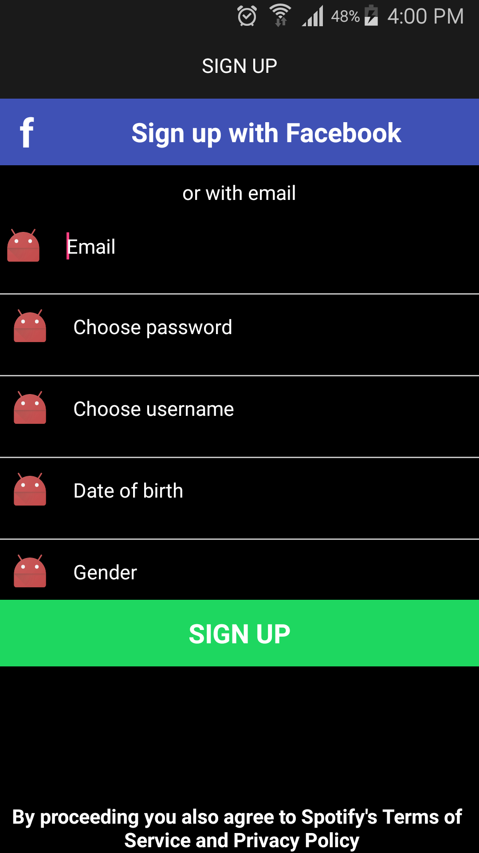

3)Search Screen.

3a)Live Search API.

3b)Search results API(Album or songs).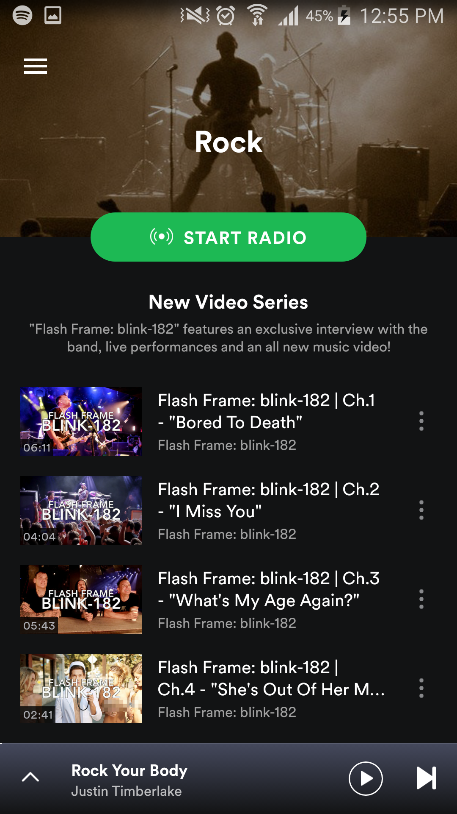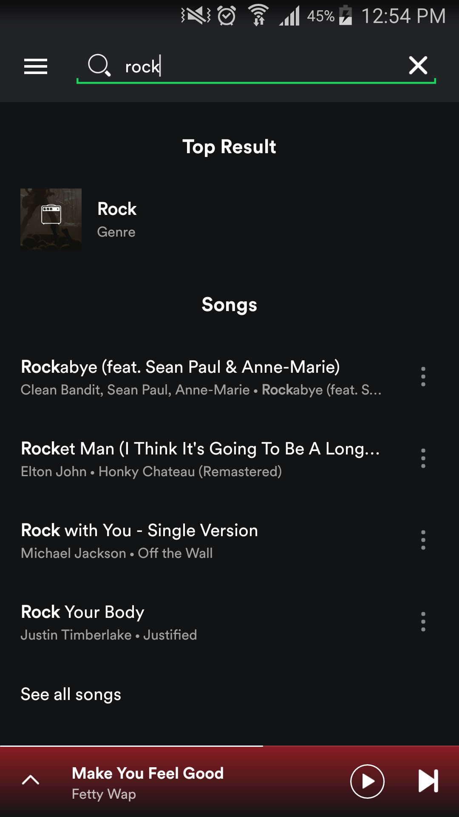

4)Home Screen.

4a)Home Screen API.

4b)List of Songs API.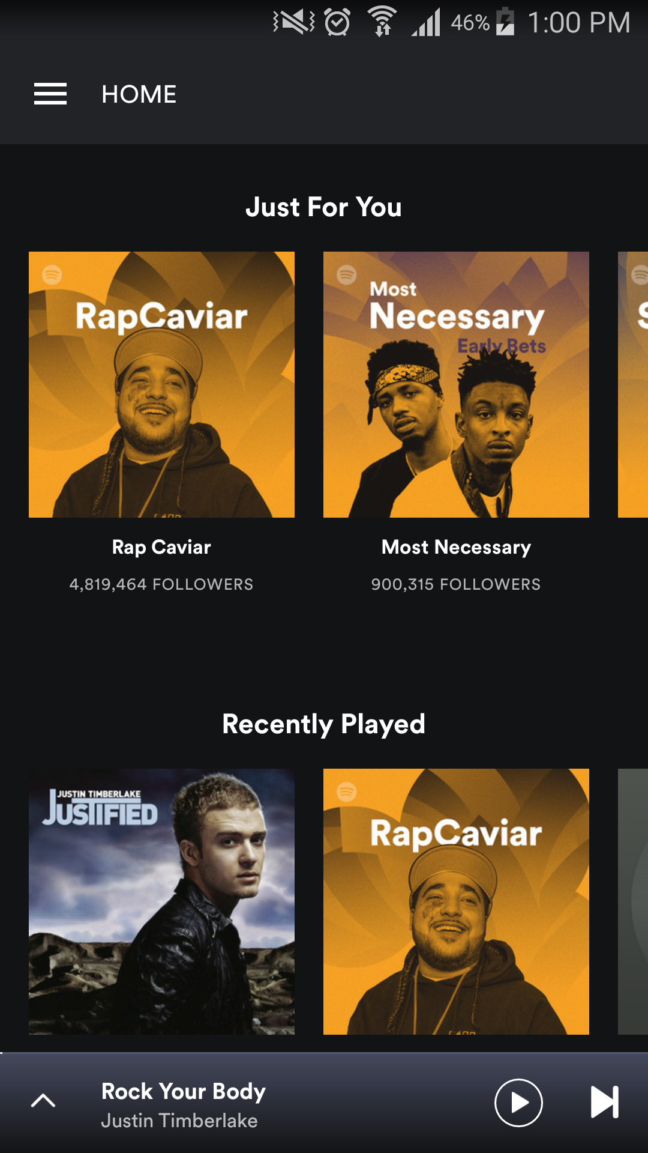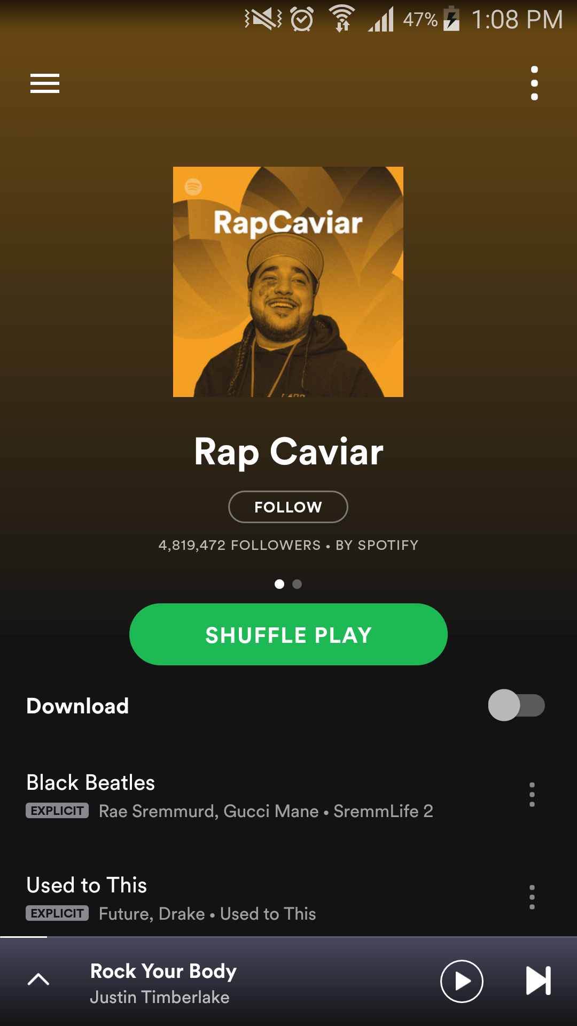

5)Browse Screen.

5)Browse Screen API : contains an list of Albums/Collections with list of tracks in each collection.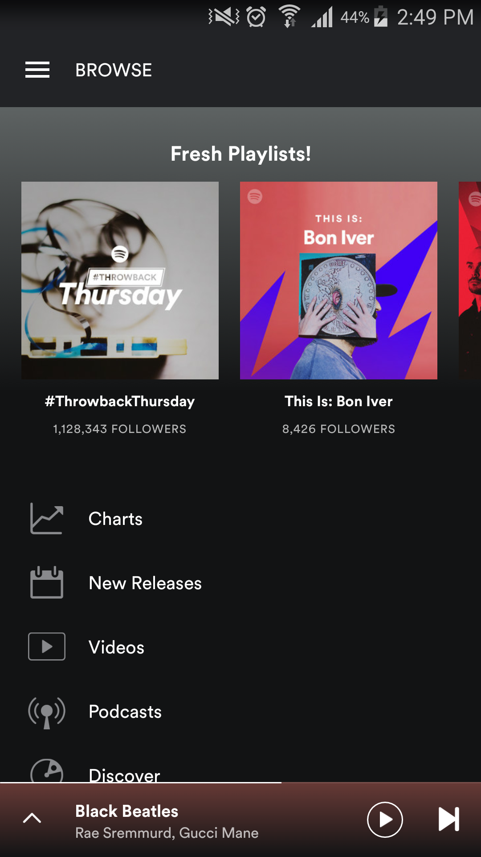

5a)Charts Screen API : contains an list of Albums/Collections with list of tracks in each collection.

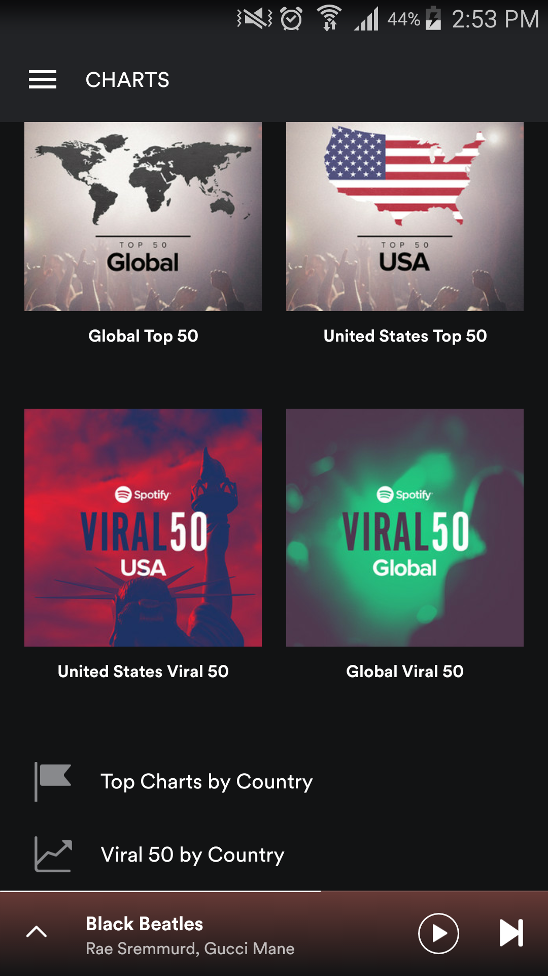

5.a(1)Global Top 50 Album songs API : : contains an list of Albums/Collections with list of tracks in each collection.

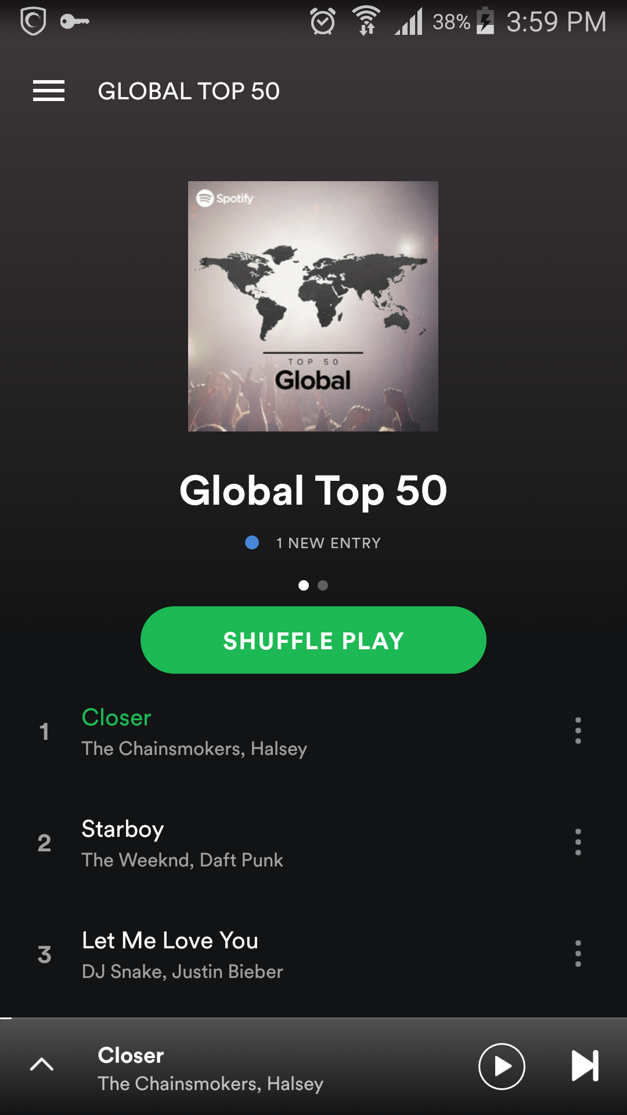

5b)New Releases Screen API : contains an list of Albums/Collections with list of tracks in each collection.

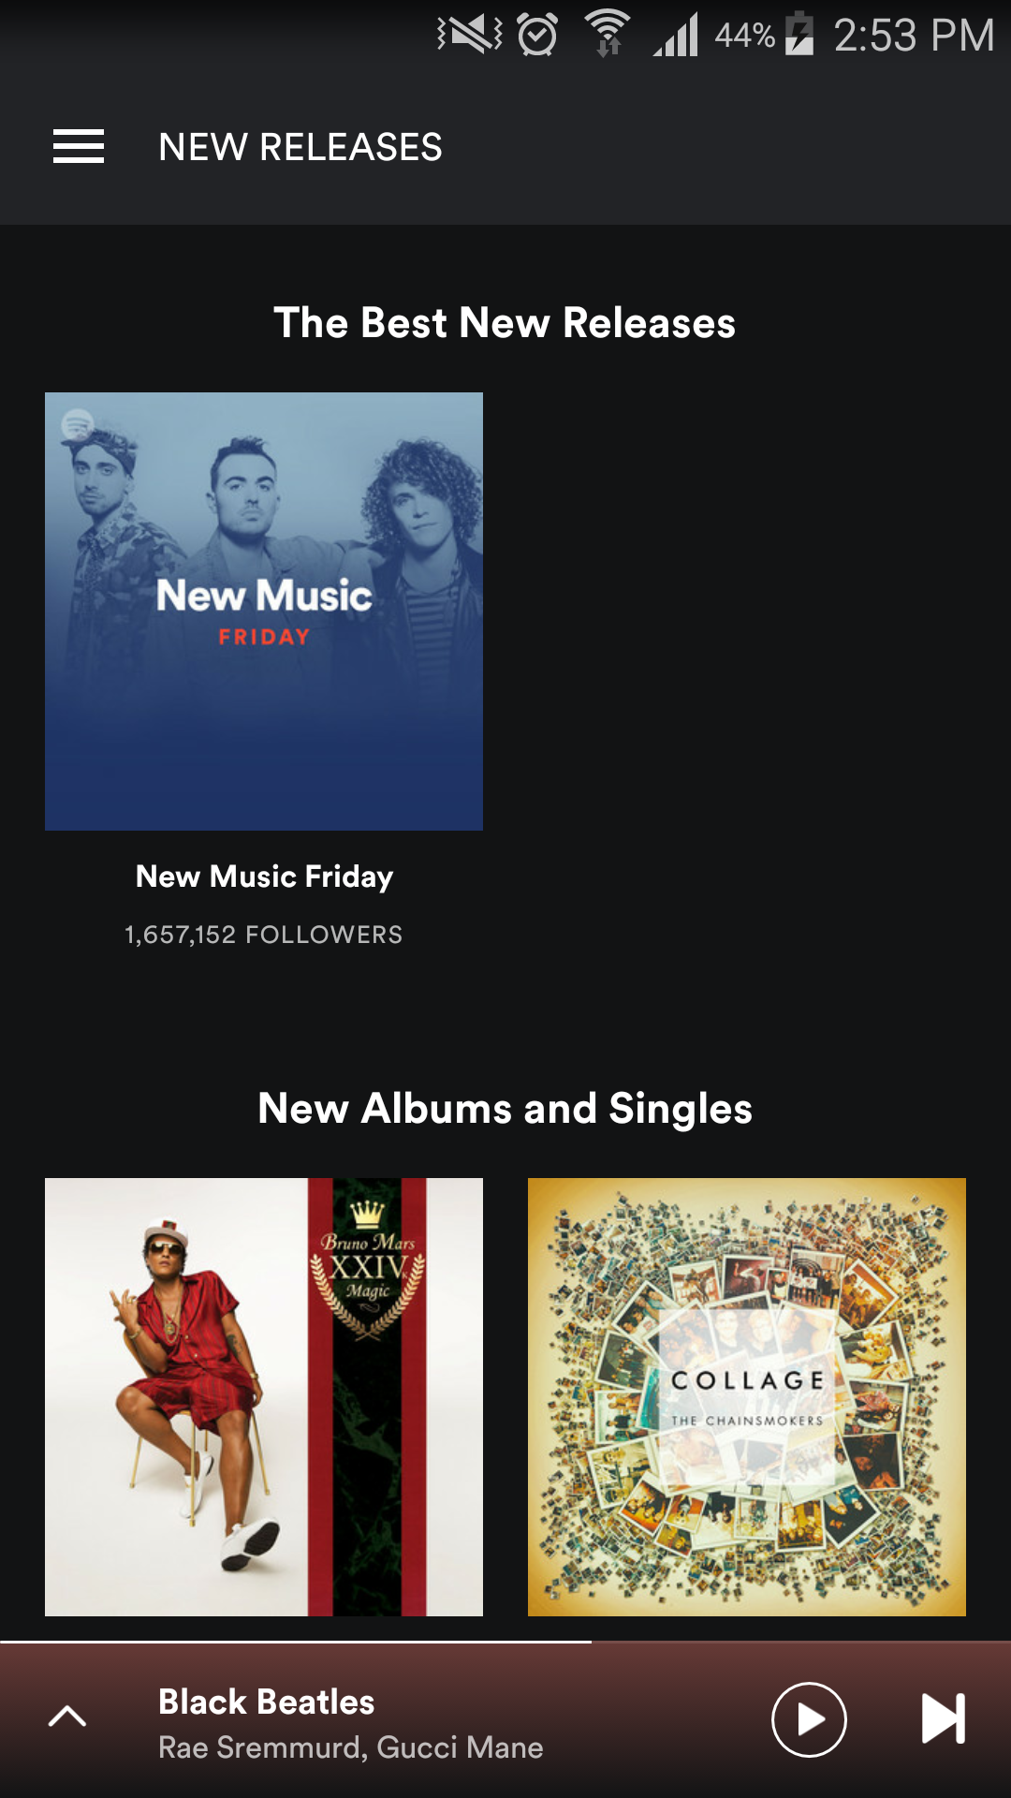

5c)Videos Screen API : contains an list of Albums/Collections with list of tracks in each collection.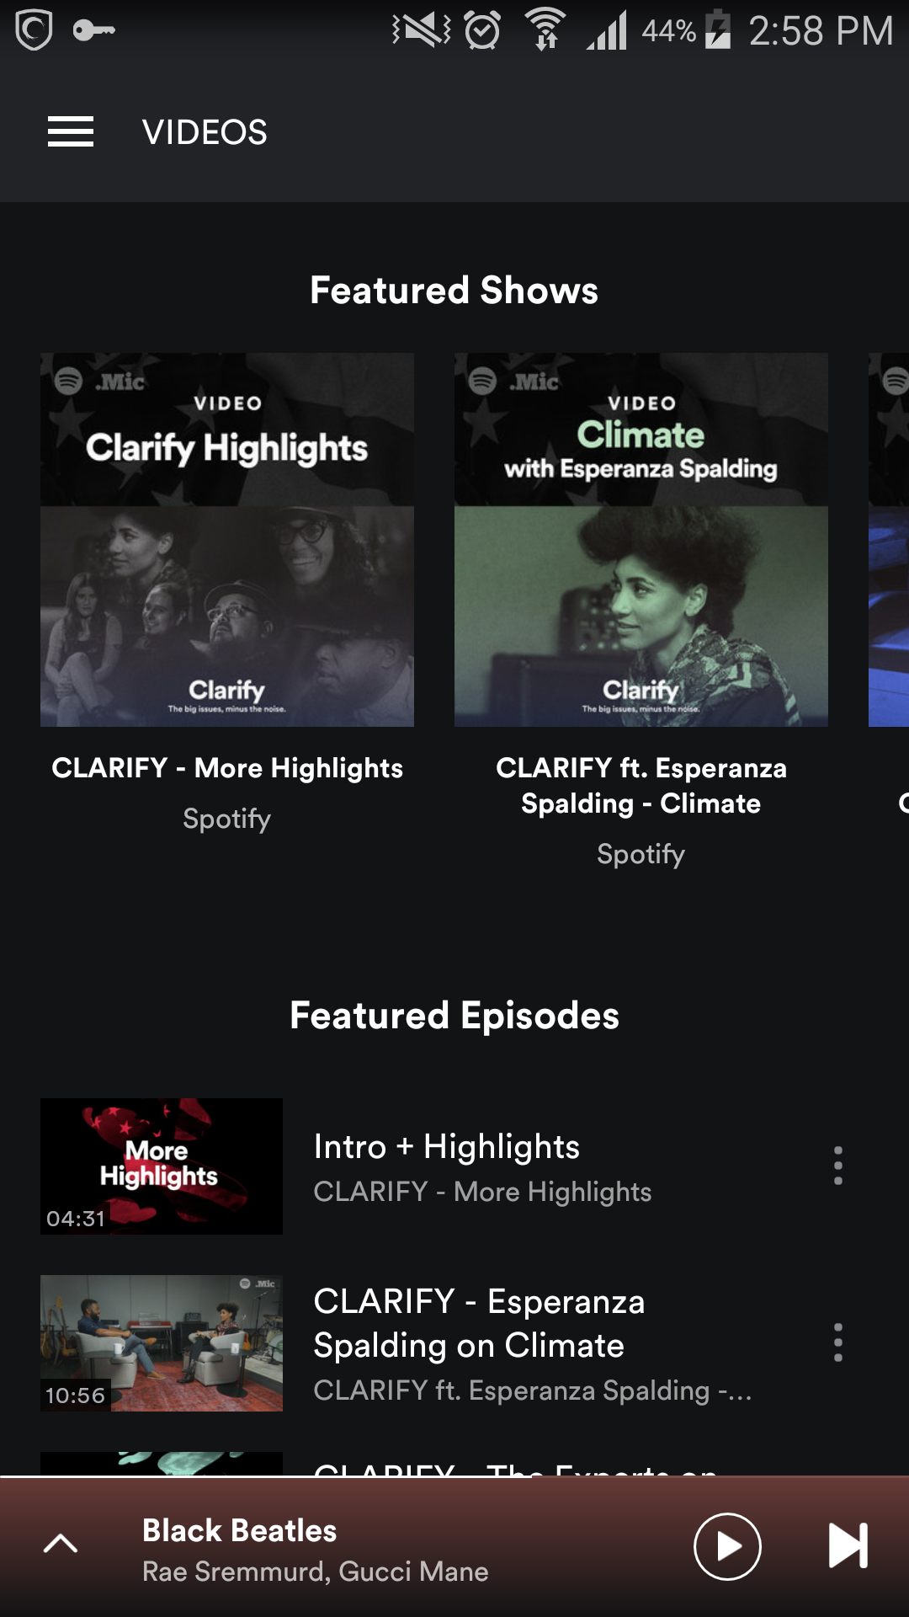

5 d) Podcasts Screen API : contains an list of Albums/Collections with list of tracks in each collection.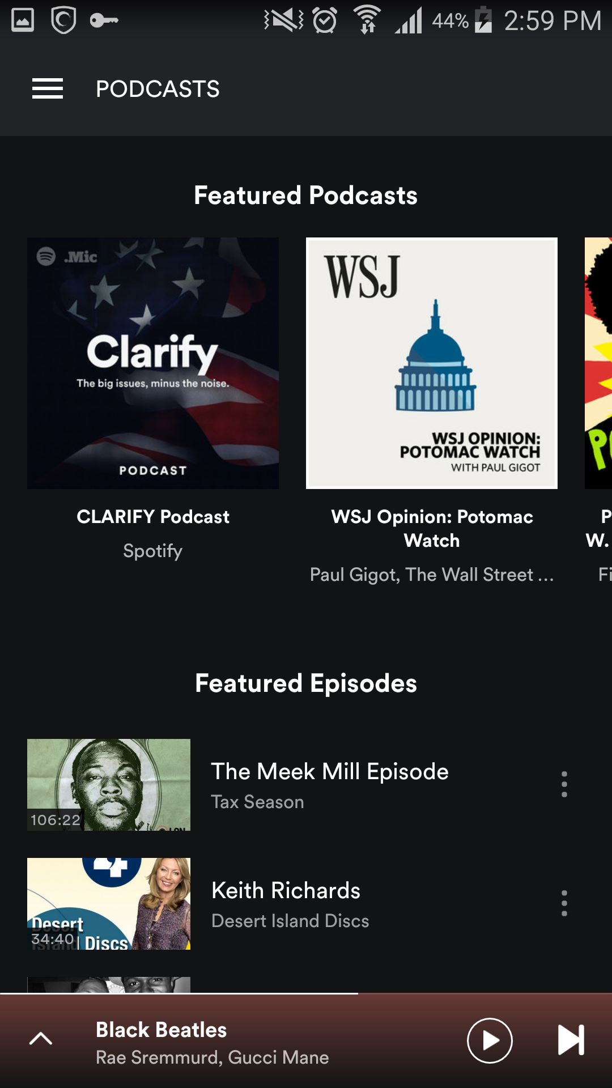

5 e) Discover Screen API : contains a list of Albums/Collections with list of tracks in each collection.

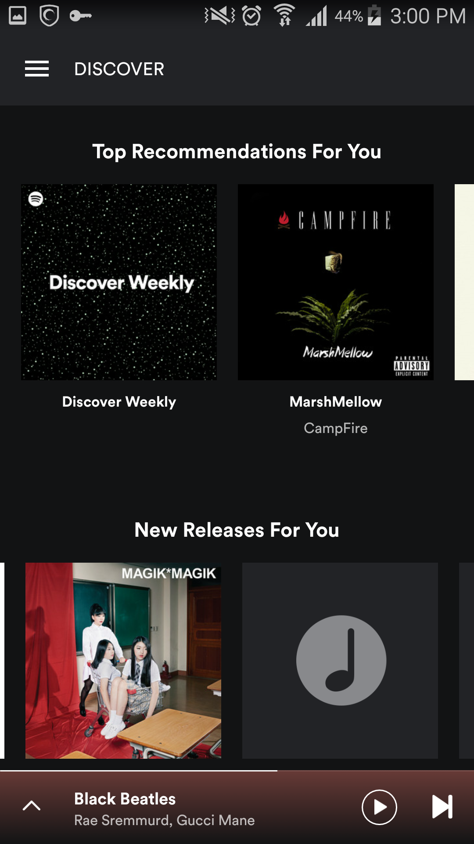

6)Radio screen.

1. Radio Screen API : contains set of Genres/Recommended stations.
2. Stations Api. (Searching & adding).

3. Each genre station contains lists of songs.

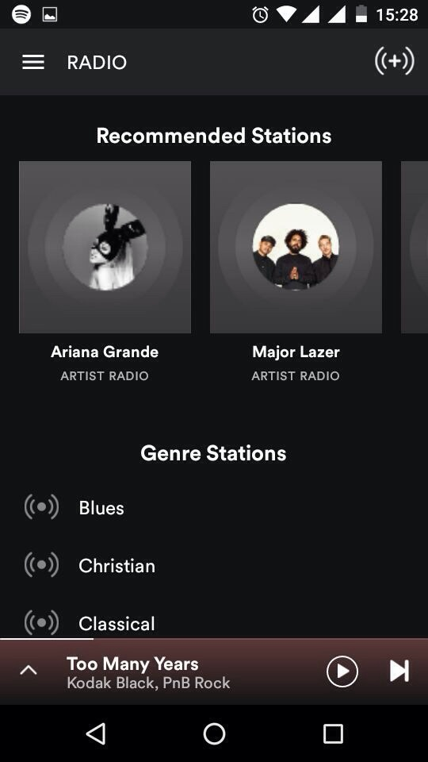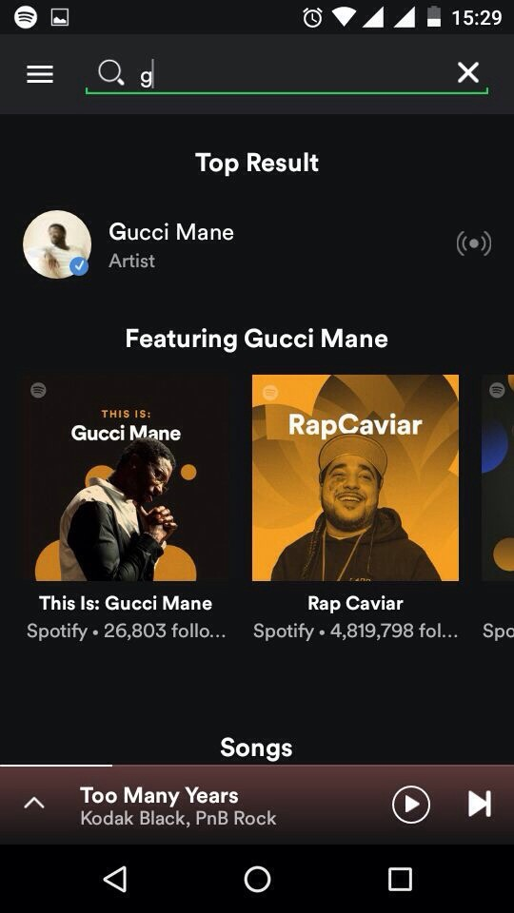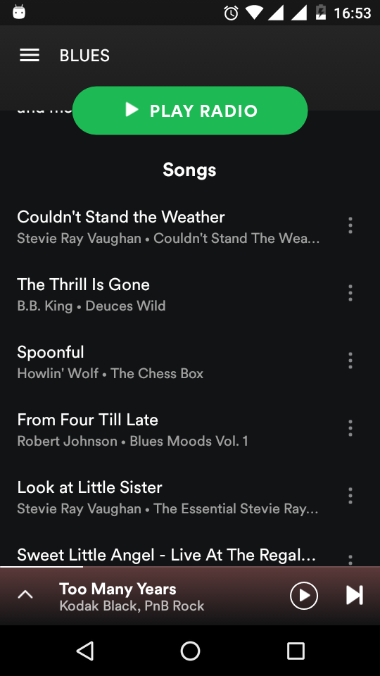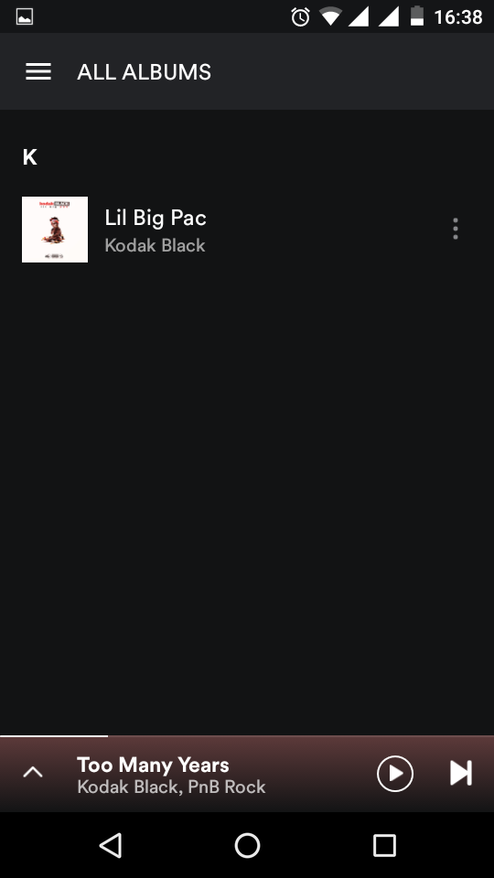

7)Library screen.

1. Library API
2. Playlists
3. Stations
4. Songs (songs added to library).
5. Albums
6. Artists
7. Podcasts & Videos.
8. Recently Played API : List of recently played tracks.

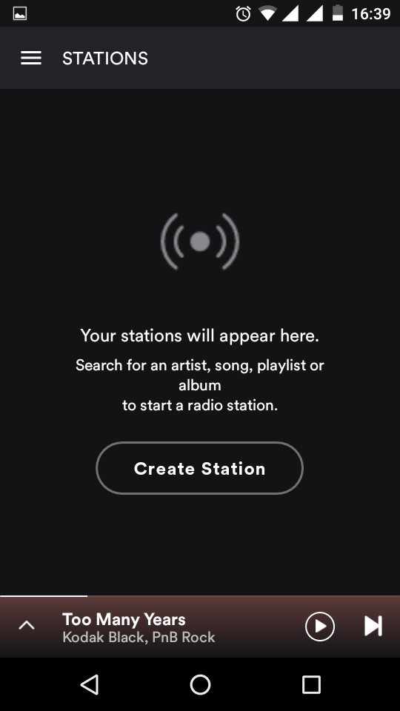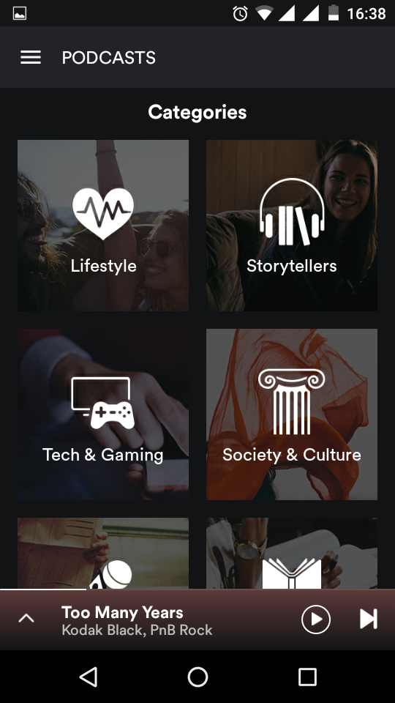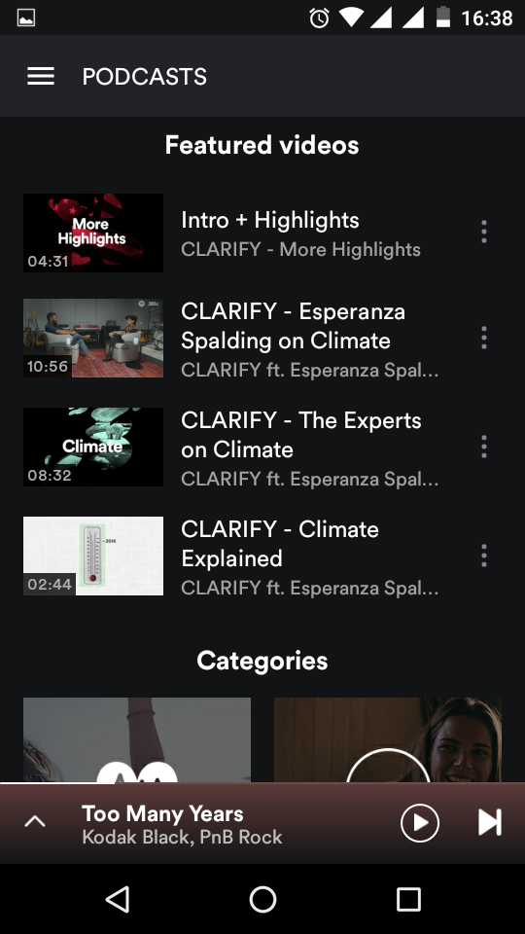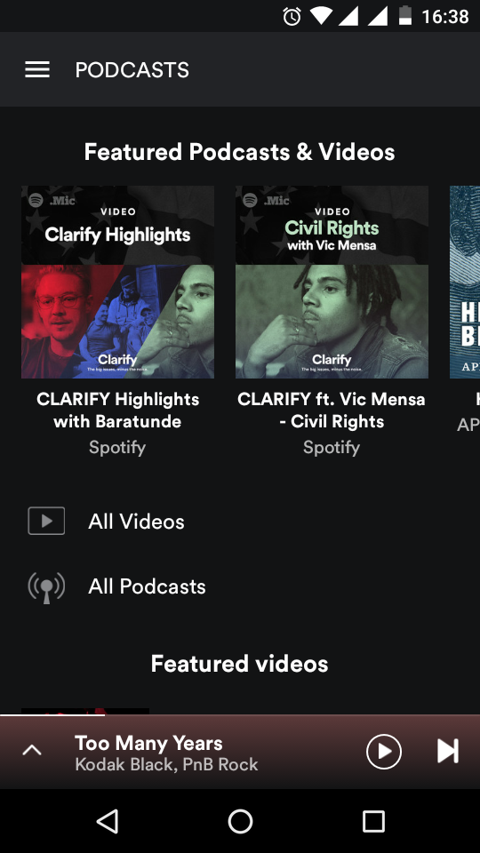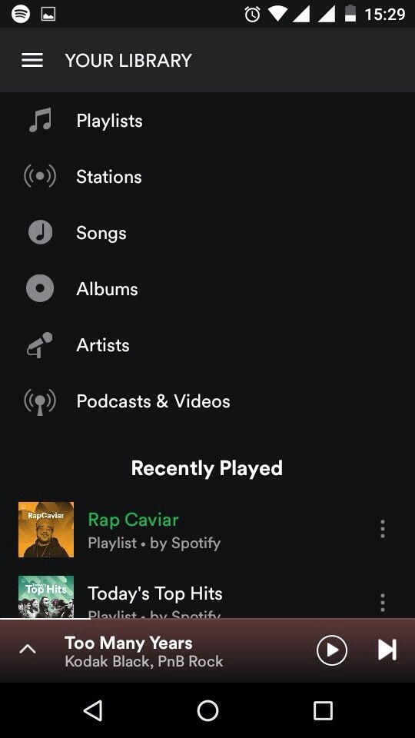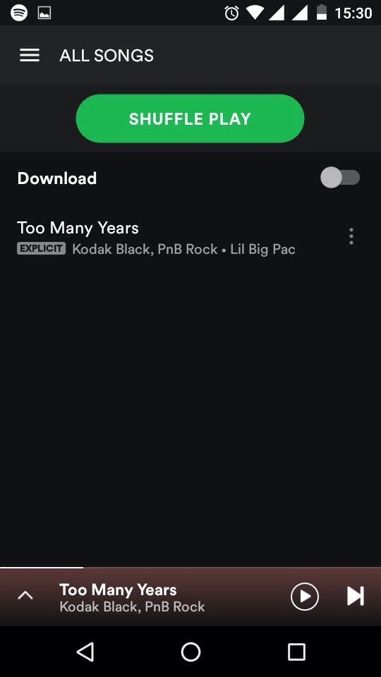

8)Slidemenu screen.

1. Profile screen API .

1.1 Adding friends.

1.2 Featured API.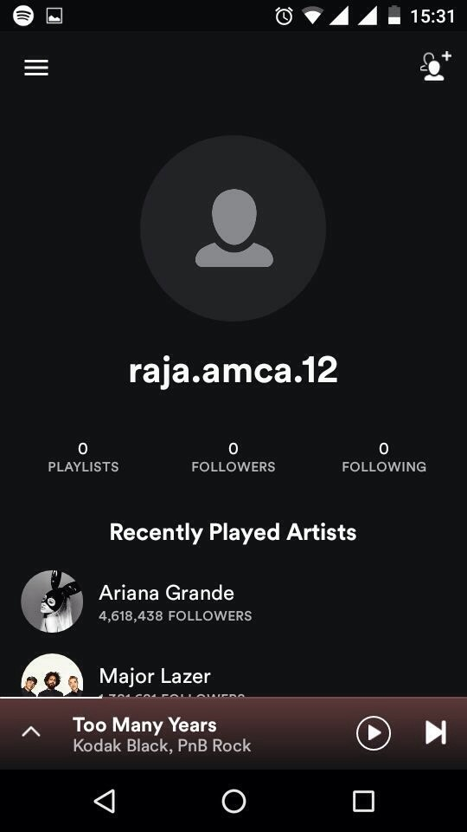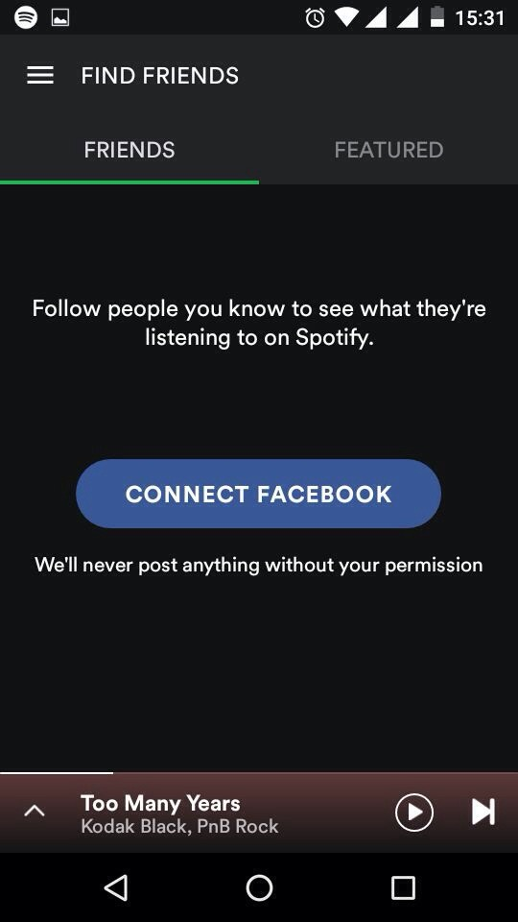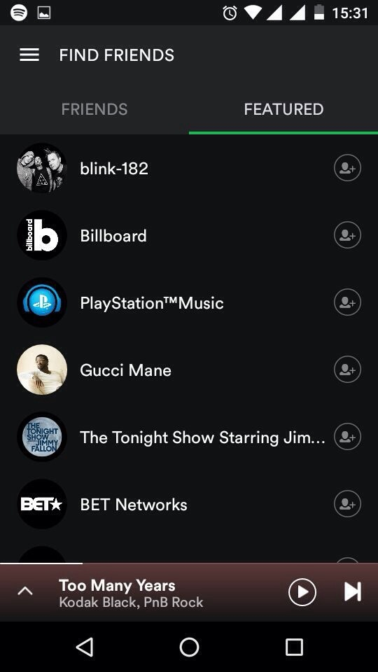

9)Go Premium screen.

1. Go Premium API (Trial version 7 days).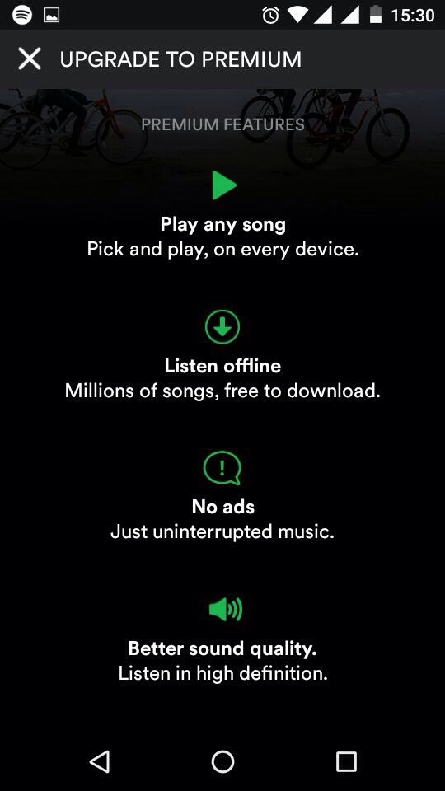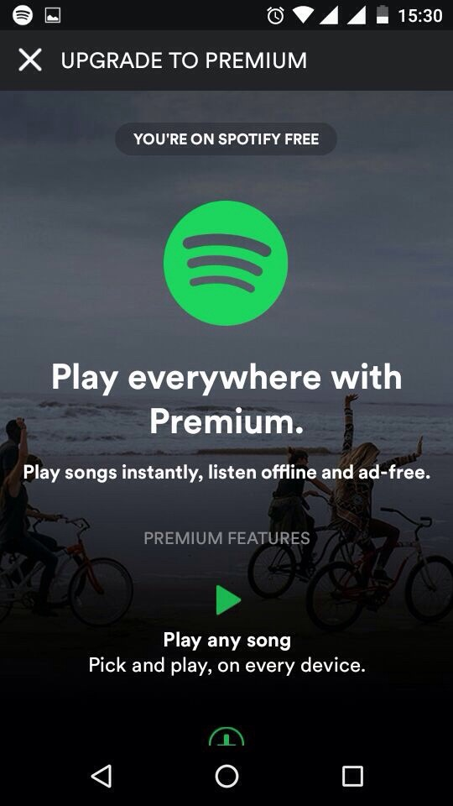

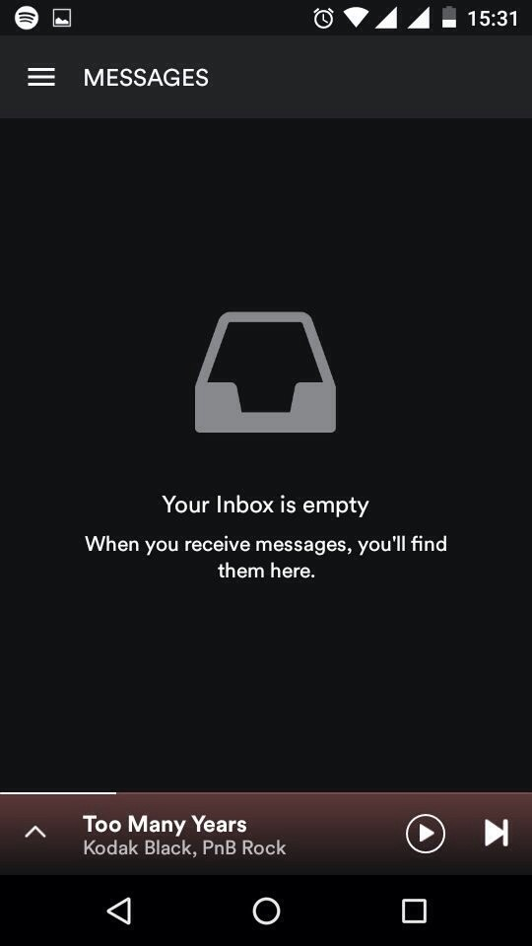

10)Message screen.

1. Messages List API : list of messages.

11)Setting screen API.

1. Settings scre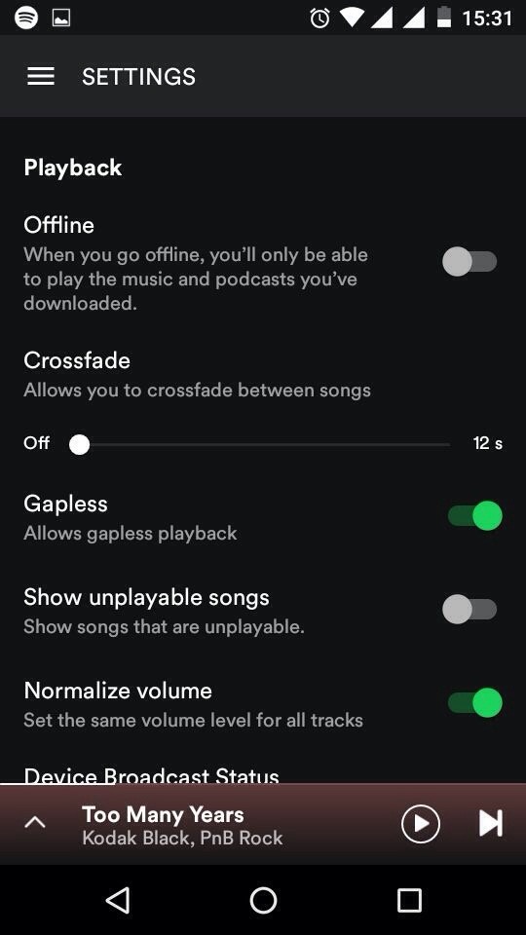en API : to read current settings.
2. Settings Update API : to update/modify settings.

